Pictograms!
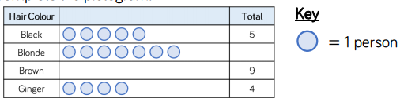
Task 1 Complete the pictogram
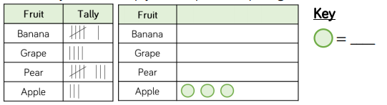
Task 2 Use your tally mark skills to help finish this pictogram!
Task 3 How could you improve this pictogram?
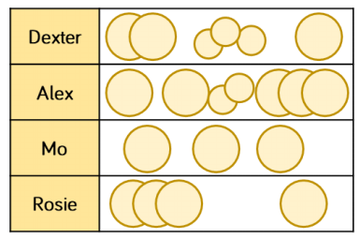

Task 4 – Use the clues to fill out of the pictogram!
• More Caramel was sold than Bubblegum flavour, but less than Strawberry flavour.
• Mint was the most popular flavour.
• Vanilla was the least popular.
