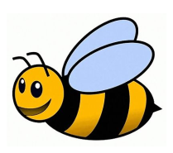
(SKILL) I am learning to understand our impact on the world around us
RESEARCH PROJECT
How have different materials had a negative impact on the planet? Create a project around one of the ideas below or your own. This can be in any way you would like.
Ideas to explore:
Clothes production
Plastic use by supermarkets
Burning of fossil fuels
Use of transport
