Year 5 & 6, Term 6 Maths Challenge
Chilton Primary School
Below is the Term 6 maths challenge. If you would like to enter, solve the problem below and return any entries to Miss Lane’s Classroom (Year 5, Team Indigo) by Tuesday 16th July. Names of those who are successful in the completion of the maths challenge will be entered into a raffle for a prize where one winner will be chosen in our Chilton Heroes assembly on Friday 19th July. All entrants will receive a certificate for participating.
Challenge:
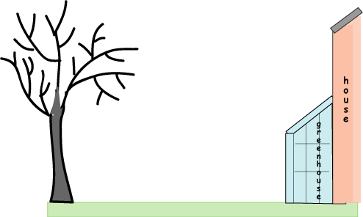
Mum, Dad and their two children, Emily and Isabel, moved into a new house. At the end of the lawn was a big tree which had a disease and was dying.
Mum said she wanted to cut the tree down before it fell down.
Dad said, "How do we know we won't hit the greenhouse?"
Mum answered," We'll measure the lawn and find out how tall the tree is!"
"How?!!" Dad, Emily and Isabel all exclaimed.
Mum said,"I'll show you!"
Emily measured the distance from the tree to the greenhouse with her metre ruler.
"Thirty-one and fourteen centimetres," Emily said.
"Now measure the shadow of the tree, you two, and make it fairly accurate!"
Emily and Dad measured the tree's shadow. Mum and Isabel pushed the end of the bamboo cane into the ground so that exactly a metre stuck out.
"Now," said Mum, "we'll measure the shadow of this cane and then we will be able to work out the height of the tree."
The shadow of the tree was 36.3 metres long and the shadow of the cane was 123 centimetres.
"It's OK," Mum announced, "it won't reach the greenhouse!"
How tall was the tree?
Top Tip: Draw a diagram of the tree and its shadow, and the stick and its shadow.
You can use a calculator to help you.

