Pictograms – varied fluency
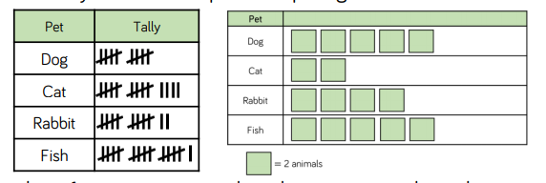
Task 1 Use the tally chart to complete the pictogram. Look carefully at the key!
Task 2 Use the information to help you complete the pictogram about the number of books read in each class
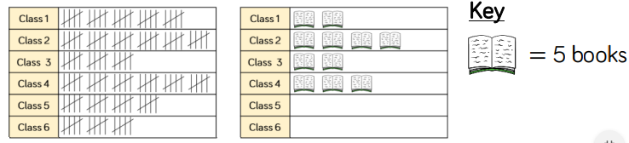
Task3 Year 1 completed a bake sale! The tally chart shows the information, can you create a pictogram to show it?
- Think about a key, could you do it in 2, 5 or 10?
- Think about your symbol, don’t go too crazy or you will get tired of drawing it!
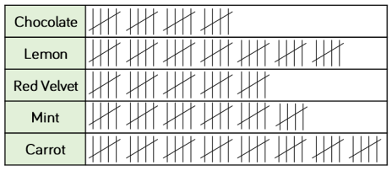

Chocolate
Lemon
Red Velvet
Mint
Carrot

= ________ cakes

