Wednesday 24th June
Year 3/4 common exception words Crossword
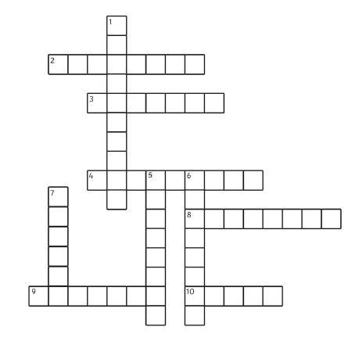
Clues
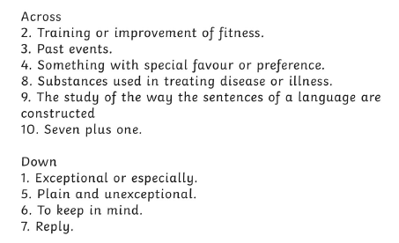
Words
favourite eight exercise particular medicine
history ordinary remember
grammar answer

