16.3.20

I am learning to identify angles
- Label the angles:
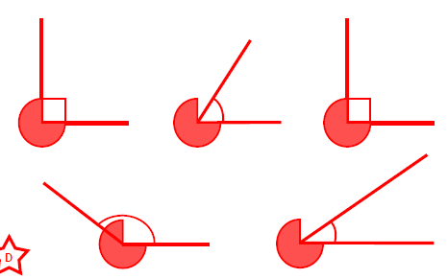
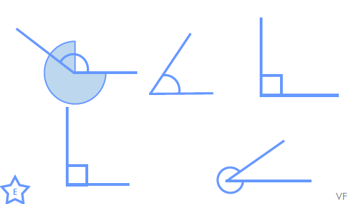
- Use >,< and = below:
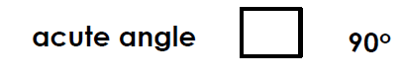
- Match the angles that when added together will still make an acute angle.

- Draw an obtuse and acute angle in your maths book and label.
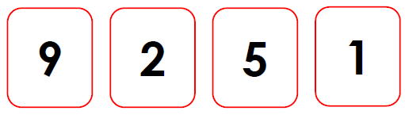
CHALLENGE: Using the digits below, how many acute angles can you make?

