The Early History of Chocolate
Use the words in the word bank to fill in the gaps.
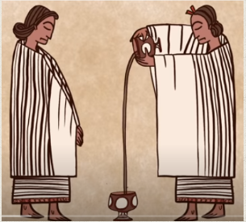
The history of chocolate starts about _____________ years ago in Central ____________________. The people living in this area then were called the _____________________. They grew cocoa beans on cacao trees and used the beans to make a frothy, bitter drink called ______________________________. They often put ________________ in their chocolate drink; it was not a sweet drink like our hot chocolate nowadays. They poured the drink from cup to cup to make it _____________________.

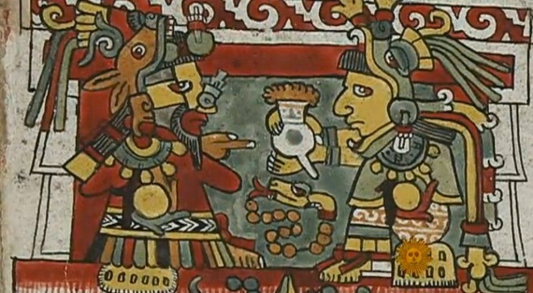
After the Mayan people, the ___________________ people came to live in Central America. They learnt about how to make the chocolate drink from the Mayan people. An Aztec king called __________________________ II loved chocolate and legends say that he drank a _____________________ of chocolatl a day! They thought that the gods gave them the cocoa beans and they used the beans instead of _____________________ to trade.

WORD BANK
Aztec chocolatl frothy gallon
Montezuma 2000 Mayans
chilli money America

