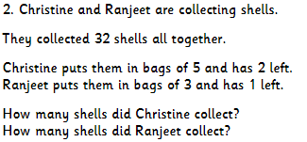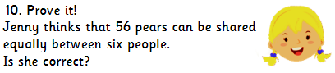

Hot

1. __ ÷ 7 = 6
2. 924 ÷ 6 =
3. 6 x __ = 48
4. 3759 3 =
5. How many remainders would you get by dividing 5418 by 5?
6. Mr Mason says that he can work out 84 divided by 6 by knowing his times tables. Which times tables would he need to know? Explain your answer.

On Fire

1. __ ÷ 8 = 7
2. 31,635 ÷ 9 =
3. 7 x __ = 35
4. __ x 3 = 360
5. Mrs Cousins says that she can work out 168 divided by 14 by knowing her times tables. Which times tables would she need to know? Explain your answer.

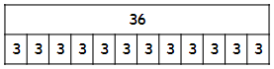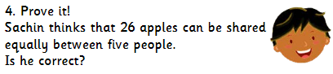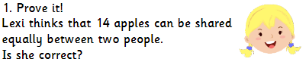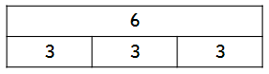

Mild

1. Write this as a number sentence for division and multiplication:

5. What division and multiplication number sentences could this bar model represent? Explain your answer.

Spicy

1. 416 ÷ 4 =
2. 144 ÷ 6 =
3. __ x 5 = 35
4. 2 x __ = 284

**9**

2. What division and multiplication number sentences could this bar model represent? Explain your answer.

?