Pictograms – varied fluency
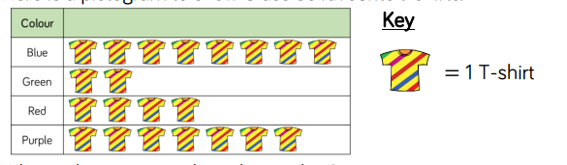
Task 1 – This is Class 5s favourite t-shirts.
- What is the most popular colour t-shirt?
- What colour is the least popular t-shirt?
- How many more children chose blue over red?
- How many children are there in the class?
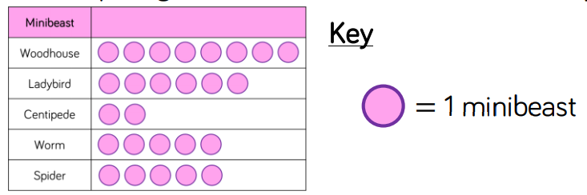
Task 2

There are ____ ladybirds.
There are ____ centipedes and worms altogether.
There are ____ more worms than centipedes.
What else does the pictogram tell us?
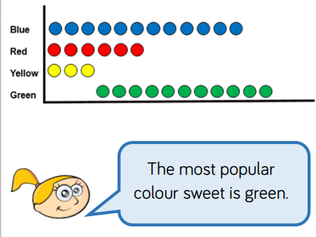
Task 3
Do you agree or disagree with Eva? Explain your reasoning.

Task 4 - Teddy writes these statements about his pictogram:
• There were more cows than sheep.
• There were the same number of sheep and horses.
• There were more chickens than any other animal.
• There were less cows than goats.
• There were 8 goats
Can you draw a pictogram so that Teddy’s statements are correct? What title would you give it?
Chickens | Cows | Sheep | Goats | Horses

