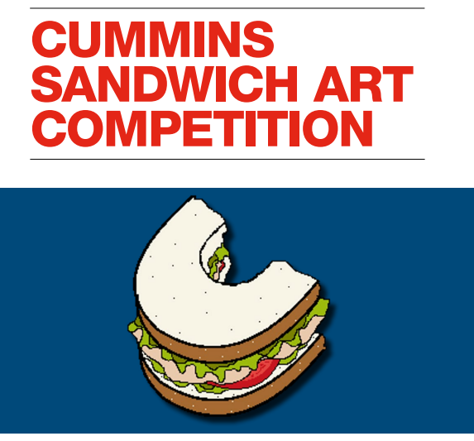
Cummins Sandwich Art Competition - Home learning

Cummins has recently relocated its Kent office to Discovery Park in Sandwich and the office is referred to as ‘Cummins Sandwich’. To celebrate the new office, we would like you to design a Cummins ‘sandwich’ – will it be traditional, retro, engineering inspired or packed with history! Winning entries will be displayed in the Cummins Sandwich office.
Submit by the 8th June 2022 through the class teacher.
THE RULES
Entrants must be a pupil from one of the Viking Academy Trust schools.
Only one entry per pupil. Entries must be A4 paper (portrait or landscape)
Entries can be in any artistic form, such as pen, pencil, paint, crayon, or collage etc.
Written on the back of all entries must be the pupil’s first name, surname initial, school name, and class name/year group

THE PRIZES

Winner per year group, per school – receives an individual prize
Overall winner per school – wins a family prize
Overall winning school – the school will receive a prize for their outdoor learning space.
