22.04.20
I am learning to solve problems involving Roman Numerals
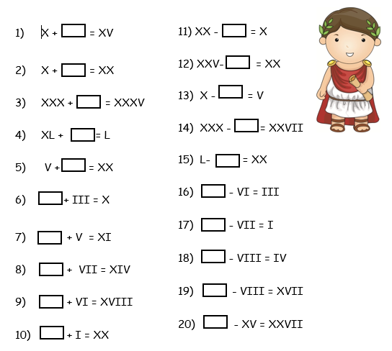
CHALLENGE – Write a number in Roman Numerals between 300 and 310.

