Friday 5th June - Fractions!
Task 1 – Shade 1 third of these shapes.
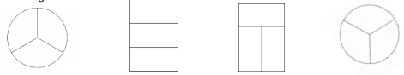
Task 2 – Tick the shapes that have been coloured in a third.
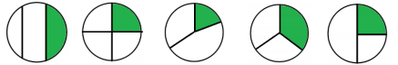
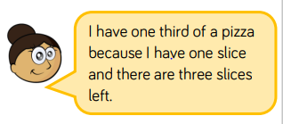
Task 3 – Beth says…. Can Beth be right?

Task 4 - Alex, Annie and Whitney each show a piece of ribbon.
Whitney shows 1/2 of her whole ribbon
Alex shows 1/4 of her whole ribbon.
Annie shows 1/3 of her whole ribbon.
Whose whole piece is the longest? Whose is the shortest? Explain why.

