I am learning to compare and order money

Use > < and = to compare the amounts below:

- 3446p and £34.46
- £10.24 and 1420
- 9949p and £99.39
- 3582p and £34.28
- 678p and £67.80
- £11.09 and 1199p

Order the amounts from smallest to largest:
- 199p, £1.52, 156p, £1.05, 100p, £2
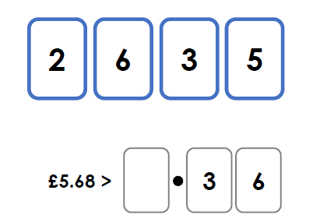
- 4732p, £92.97, 1386p, £13.99, £31.99

- How many ways can you make this true?
CHALLENGE
Angela has been saving 50p pieces. She has more than 3450p but less
than £37. How much could Angela have?

