Tuesday 15th December 2020
I am learning to identify odd and even numbers
1, 3, 5, 7, 9, odd numbers, they are fine!
0, 2, 4, 6, 8, even numbers they are great!

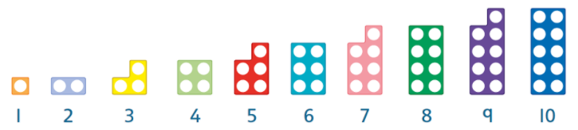

Even numbers always have a partner. Odd number always have an odd one out. We always look at the ones digit to tell if a number is odd or even.
14 is even because there is a 4 in the ones column and 4 is even.
23 is odd because there is a 3 in the ones column and 3 is odd.
Sort the numbers in to odd or even:
2 7 6 5 9 10
11 13 15 12 20 14
45 24 32 41 26 35

Odd Even

Katie says that 14 is odd because there is a 1 in the number. Is she right or wrong?

